**1: Executive Summary**

The way customers allocate their spending on products and services in a free market is called consumer preference. Their interests, likes, prior experiences, and a variety of other factors that can differ from person to person provide the basis for these preferences.

The notion that a customer prefers one product or service over another based on his evaluation is not unique. The ability to identify and measure the elements / factors that come into play when a buyer prefers one product over another; such preferences can now be studied by marketers in order to provide better products and services.

Britannia need to use advertisement strategy in biscuits products. The quality and packaging factor is the most important factor while buying the product. As observed customer do see the packaging also.

Given that both customers and retailers are a part of the organisation, there is a greater need to understand their behaviour. By launching a value club for retailers, the goal is to foster and sustain a feeling of connection with the business while allowing members to express ideas, viewpoints, questions, and insights that will assist the business develop its goods and services.

I have learned a lot about several problems with the conventional customer satisfaction study by conducting research in this area. One of the most significant lessons I took away from this project was that great customer happiness does not necessarily translate to high consumer preference or loyalty. For all the right reasons, including product quality, flavour, pricing, brand image, and others, businesses need to be on consumers' minds.

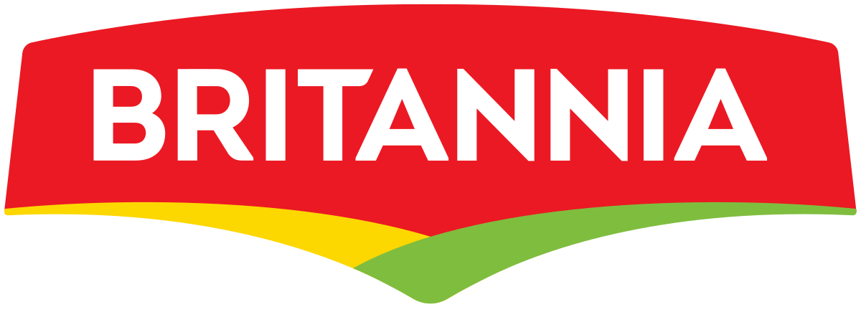

# 2: Industry overview

**Introduction** **-** The largest food industry in India is the biscuit industry, which has an annual revenue of over Rs. 3000 crores. India is regarded as the world's second-largest biscuit producer, after the United States. There are two categories for it: organised and disorganised. Around 80% of all bakery items sold in India are made up of bread and biscuits, which dominate the sector. Bread is produced and valued at a lower level than biscuits. This makes up more than 70% of the unorganised sector of the baking industry.

In the latter half of the 20th century, as demand for ready-made food goods at reasonable prices increased in the urbanised society, the India Biscuits Business came to the forefront and began developing a solid reputation in the baking industry. In the past, biscuits were thought to be an ill person's diet. It is now one of the fast-food items that people of all ages like the most. Biscuits are convenient to transport, delicious to eat, cholesterol-free, and inexpensive. State-wise, Maharashtra, West Bengal, Andhra Pradesh, Karnataka, and Uttar Pradesh have the highest biscuit consumption rates. The states with the highest levels of industrial development, West Bengal and Maharashtra, also consume the most biscuits. Even still, the rural sector consumes about 55% of the bread items' biscuits.

# 3: Industry Analysis

## 3.1: Size of the Industry

The Biscuits Market is anticipated to grow at a CAGR of 4.9 percent from 2020 to 2025, reaching a value of $129.1 billion. Flour, sugar or salt, butter or vegetable shortening, and baking powder act as leavening agents in the creation of biscuits. They are baked foods with a flour basis that are eaten as snacks. These culinary items come in a variety of flavours, varieties, tastes, and textures. In general, biscuits have a sweet flavour since they are made of sugar or honey, but some varieties can have savoury or salty flavours. One of the most well-known and popular packaged snacks worldwide is the biscuit. A range of substances, such as nuts, chocolate flavour, chocolate chips, and sandwich fillings, can be combined with them.

1. **Key takeaways**

* Geographically, Asia Pacific is the area with the greatest market share for biscuits in 2019, thanks to rising consumer demand there.
* The global biscuits market is expected to increase favourably as consumer disposable income rises and middle-class populations' living conditions change across the globe.
* With nearly no entry barriers and almost complete product penetration, there is fierce competition in the market, which is expected to boost demand for the market over the projected period of 2020–2025.

1. **By Type - Segment Analysis**

* Crackers & Savoury and Sweet Biscuits are two types of biscuits available on the global biscuits market. The market for biscuits worldwide in 2019 was dominated by the sweet biscuit category. During the projected period of 2020–2025, the market for filled sweet biscuits is anticipated to develop at the highest CAGR. Sweet biscuits are eaten all around the world because of their flavour, energy level, and accessibility. Additionally, people favour sweet biscuits because of their high nutritious content. The market for sweet biscuits is expected to expand between 2020 and 2025 as a result of customers' rising desire for ready-to-eat snacks and their ease of access thanks to the developing retail industry.

1. **By distribution channel**

* Convenience stores, independent bakers, online channels, supermarkets/hypermarkets, and others are some of the distribution channels available in the global biscuit market. In 2019, the segment comprised of supermarkets and hypermarkets holds the biggest market share. The segment for online retail is anticipated to grow at the highest CAGR of 4.99 percent from 2020 to 2025. This is because online purchasing offers more savings and more varied shopping possibilities. Additionally, the popularity of the online platform is due to doorstep delivery.
* Supermarkets and hypermarkets are self-service stores that offer a large selection of biscuits, including sweet and savoury biscuits, crackers, filled and coated biscuits, and others. Supermarkets and hypermarkets provide a wide variety of goods, including numerous brands of biscuits, all under one roof, which has aided in income generation.

1. **By Geography – Segment analysis**

* Due to the region's growing middle-class population and rising disposable income in developing nations like China and India, the Asia-Pacific region dominated the global biscuits market in terms of revenue and market share in 2019. In addition, there is a growing market for confectioneries and biscuits in this region, which is positively impacting the worldwide biscuits industry. The market's biggest CAGR is anticipated to come from Europe between 2020 and 2025. During the projection period of 2020–2025, the market in North America is anticipated to lead. This is due to an increase in sandwich biscuit consumption throughout North America, particularly among the working-class people in the United States and Canada.

## 3.2: Major players in the industry

* **Parle products Pvt. Ltd**



In 1929, the Chauhan family of Bombay’s Vile Parle established the Parle Products business. Parle began making biscuits in 1939. The company launched an advertising campaign to sell their Glucose cookies as an Indian alternative to British biscuits after India attained independence in 1947. [7] The Parle brand became well-known in India as a result of the success of products like the Parle-G cookies and cold beverages like Gold Spot, Thumbs Up, and Frooti.

* **ITC Ltd**



The 1910-founded Imperial Tobacco Company of India Limited changed its name in 1970 to the India Tobacco Company Limited, and then again in 1974 to I.T.C. Limited. Since then, the company has changed its name to ITC Limited, with “ITC” no longer serving as an acronym. As of 2019–20, ITC has a market value of US$35 billion and an annual revenue of US$10.74 billion. It employs 36,500 people and operates more than 60 locations across India.

* **Anmol Industries Ltd**



Anmol Industries Limited is a packaged food company, majorly focusing on biscuits, cakes and cookies. We have a strong presence in Northern and Eastern India and are currently making progressive efforts to establish footprints in the Southern and Western parts as well. Since 1994, we have successfully leveraged our established brand presence, strategic supply chain, diversified product portfolio and consequent value proposition for consumers to reach maximum households. Additionally, our strategically located manufacturing facilities, experienced promoters and senior management team have made relentless efforts to establish Anmol as an iconic brand across India.

* **Priya Gold: Surya food Pvt Ltd**



Gold Priya Millions of Indians have been eating biscuits for many years. The favourite biscuit in India is currently referred to as Priya Gold. Thanks to the adoration of our customers, we have quickly ascended to the top of the food market globally by offering cookies, cakes, confections, and juices/beverages. We have established ourselves as one of the industry’s top businesses thanks to the fact that our products are now available in more than 20 countries. The business has put a lot of trust in the large team of professionals that we have put together.

## 3.3: Market share of major players

1. **Britannia Industries Ltd** – Market share of Britannia is 29 %
2. **Parle products Pvt Ltd** – Market share of Parle products is 24%
3. **ITC Sunfeast** – The market share of ITC Ltd is 10%
4. **Anmol Industries Ltd** – Market share of Anmol Industries Ltd is 4%
5. **Priya Gold: Surya food Pvt Ltd** – Market share of Priya gold Pvt Ltd is 4.5%

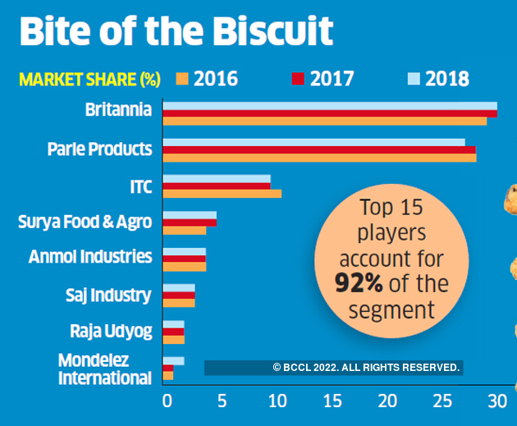

**Fig.1**

## 3.4: Challenges faced by the Industry

1. **The Tax structure : Earlire & Now** – The biscuit industry currently owns a remarkable 20,000 crore market share. Even the market giants, including Parle and Britannia, are Indian firms. This is an industry that is still dominated by Indian enterprises. The largest obstacle is expected to be the recently implemented GST. The widespread consumption of biscuits has been hampered by the arbitrary application of the 18 percent Goods & Service Tax (GST). "The government has mistakenly perceived as a luxury product by placing it in the higher tax slab denying level playing field for biscuits and similar products," claims Agarwal.
2. **Cost Escalation** – In addition to GST, excessive inflation on packaging and raw materials is once again impeding the expansion of the biscuit business. Furthermore, the government's recent initiatives to raise the minimum purchase prices for sugar and wheat in an effort to aid farmers would ultimately have an impact on the cost of biscuits. Manufacturers will also be compelled to raise prices in order to comply with the GST slab. Pankaj Agarwal, CEO of Bonn Biscuits, commented on the topic, saying: "The biscuit industry is prone to an increase in the cost of inputs/ingredients due to rising costs for transportation, fuel, packaging, salaries, etc.
3. **Retail Challenges** – The majority of biscuit sales are still made through general merchants. "We are having several difficulties at the retail level. When a shopkeeper sells various food items marked with various GST slabs, it is difficult to bill or sell. And this is one of the main reasons people don't switch to using plastic money to buy biscuits. We are asking the government to impose a uniform GST slab on all food goods because of this. The director of Surya Food & Agro Ltd., Shekhar Agarwal, said (Priya gold Biscuits). Aside from little cookie manufacturers, no one is brave enough to start direct retail. "Given the magnitude of the industry, nobody can thrive by launching their own direct stock; it is just not conceivable."for vast companies to have their exclusive retail distribution.
4. **Low acceptance of Mid & Premium segment biscuit –** Most of India's urban population, specifically, is responsible for the demand for mid- and premium-priced biscuits. Due to their exorbitant pricing, such products are not widely accepted in the country's rural areas. Due to their low cost and higher quantity, glucose biscuits are preferred by rural consumers. Due to issues like the monsoon deficit and others that cause lower income, marginal consumers whose income growth does not keep pace with inflation are unable to spend on non-necessities items, it is anticipated that the demand for these economy segment biscuits in rural India will continue to be negatively impacted in the upcoming years.

# 4: About the company

One of India's top food firms, Britannia Industries has a 100-year history and generates more than Rs. 9000 Cr in annual revenue. Britannia is one of the most reputable food companies, producing well-known products in India as Good Day, Tiger, NutriChoice, Milk Bikis, and Marie Gold. The product line offered by Britannia consists of biscuits, bread, cakes, rusk, and dairy items like cheese, beverages, milk, and yoghurt. Many generations of Indians have grown up with the Britannia brand, and our brands are cherished and adored in India and around the world. Over 50% of Indian homes are served by the near to 5 million retail locations where Britannia products are sold throughout the nation.

Around the world, we are present in more than 60 nations. Our global reach includes a local manufacturing base in the Middle East, where we are the No. 2 biscuit player in the UAE and have a strong claim to the leadership. We also have a similarly strong market position in the other GCC nations. In Nepal, where we are also the market leaders, we are in the midst of investing in a production facility.

In 2009, the business established the Britannia Nutrition Foundation and started working on public-private partnerships to reduce malnutrition among disadvantaged mothers and children. In numerous polls undertaken by major companies like Millward Brown, IMRB, WPP Group, and Havas Media Group, to name a few, Brand Britannia is named among the most dependable, valued, and well-liked brands.



Britannia considers "Taste & Trust" to be its brand name, and it will continuously work to get a billion Indians to reach for a delicious and nutritious Britannia product multiple times per day!

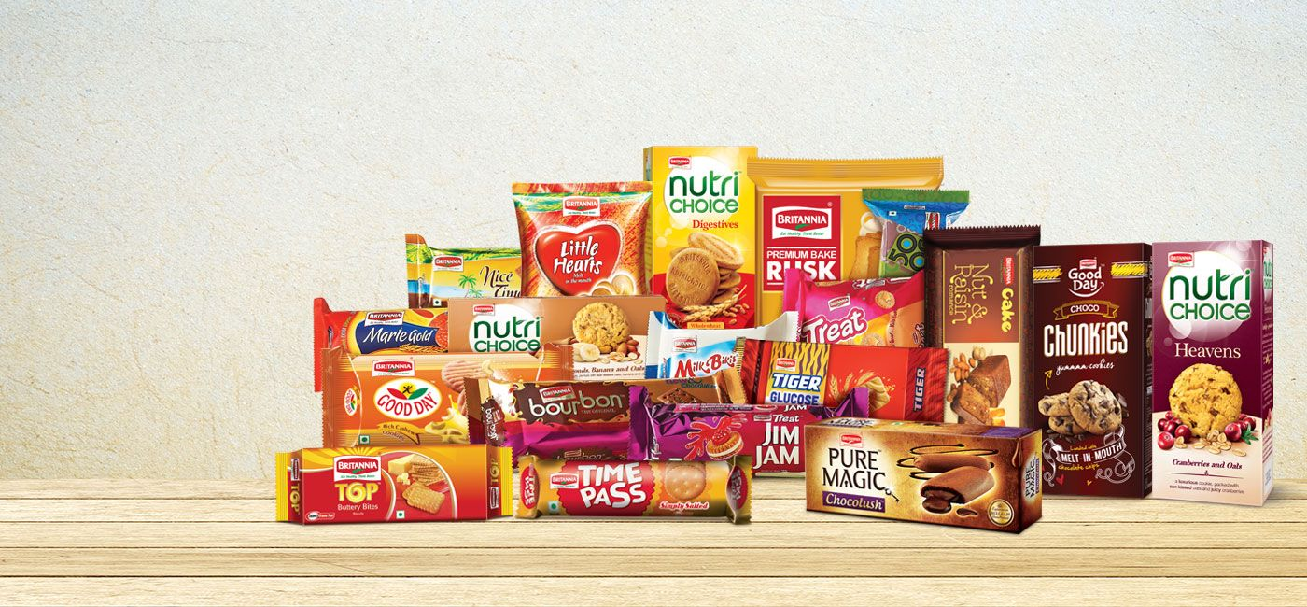**Fig.2**



## 4.1: Products

1. **Biscuit**

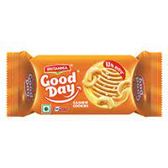

A baked and formed food item made of flour is called a biscuit. Biscuits are typically flat, firm, and unleavened in the majority of countries. They can be created with sugar, chocolate, frosting, jam, ginger, or cinnamon and are often sweet**.**

1. **Bread**

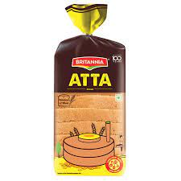

A wheat- and water-based dough is used to make bread, which is then typically baked. It has played a significant role in many cultures' diets all around the world and throughout recorded history. It is one of the earliest foods manufactured by humans.

1. **Cake**

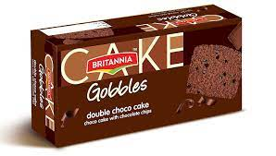

Cake is a flour dessert that is typically baked and is created with flour, sugar, and other ingredients. Cakes were originally bread variations, but today they refer to a wide variety of dishes that can be made simply or elaborately.

1. **Rusk**

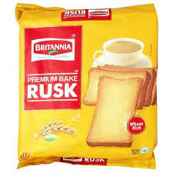

A rusk is a two-baked loaf of bread or a firm, dry biscuit.  Babies use it occasionally as a teether.  Cake is frequently referred to as cake rusk in countries where rusk is made from cake rather than bread.

1. **Cheese**

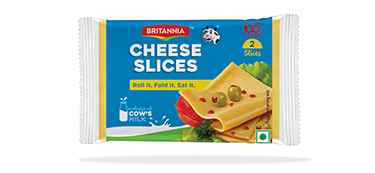

Cheese is a dairy product made from the coagulation of milk protein casein. It comes in a broad variety of flavours, textures, and forms. It is made out of milk-derived proteins and fat, typically from the milk of cows, buffalo, goats, or sheep.

1. **Milk**

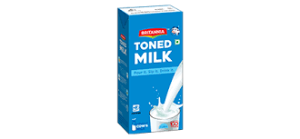

A nutrient-rich liquid diet called milk is created by mammals' mammary glands. Before they are able to digest solid food, it is the main source of sustenance for young mammals (including breastfed human new-borns).

1. **Yoghurt**

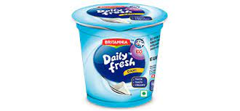

A meal called yoghurt is created when bacteria in milk ferment. Yogurt cultures are the bacteria that are used to manufacture yoghurt.

## 4.2: Position in the Industry

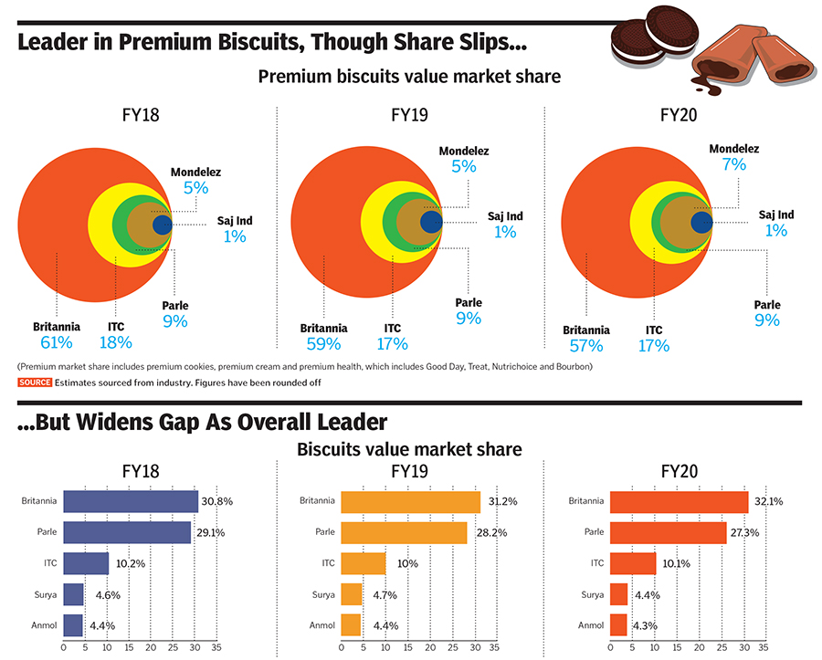

**Fig.3**

Britannia has ranked 1st in the market share of biscuits over the years and kept the legacy to become the best biscuit brand in India. Britannia Industries have a revenue of 11,878.95 cores INR (US$1.6 Billion). Britannia Industries is a leading food company in India, with a 100-year history and annualrevenues in excess of Rs. 9000 Cr. Britannia is one of the most trusted food brands in India,producing well-known brands such as Good Day, Tiger, NutriChoice, Milk Bikis, and MarieGold. Britannia’s product line includes Biscuits, Bread, Cakes, Rusk, and Dairy items such asCheese, Beverages, Milk, and Yoghurt. Britannia is a brand that many generations of Indianshave grown up with, and our brands are beloved in India and around the world. Britanniaproducts are available in nearly 5 million retail outlets across the country, reaching morethan half of Indian households.

## 4.3: Locational and Operational details

|  |  |
| --- | --- |
| Location Type | Address |
| Registered Office | 5/1/A Hungerford Street Kolkata – India FAX – 91-033-22872501 Phone1 – 91-033-22872439/2057/2287 Phone2 – N.A. Email – Investorrelations@Britindia.Com |
| Development Centre | #77 S P Industrial Estate Meenakshi Building Chennai – India FAX – N.A. Phone1 – 91-44-30216000 Phone2 – N.A. Email – N.A. |
| Others | 15 Taratola Road Kolkata – India FAX – N.A. Phone1 – 91-33-30437041/30437069 Phone2 – N.A. Email – N.A. |
| Others | Plot No-1 Sector-1 Integrated Industrial Estate Udham Singh Nagar – India FAX – 91-5944-304810 Phone1 – 91-5944-304814/15/816 Phone2 – N.A. Email – N.A. |
| Others | Prestige Shantiniketan Tower C 16 & 17 Flr Whitefield Main Rd Bangalore – India FAX – 91-80-25263265/25266063 Phone1 – 91-80-39400080 Phone2 – N.A. Email – Investorrelations@Britindia.Com |
| Others | 33 Lawrence Road Britannia Chownk New Delhi – India FAX – N.A. Phone1 – 91-11-30688000 Phone2 – N.A. Email – N.A. |
| Others | India Land & Properties Ltd One Indiabills Park #14 Tow-B Chennai – India FAX – N.A. Phone1 – 91-44-30216000 Phone2 – N.A. Email – N.A. |
| Others | Plot No F-21 Industrial Estate Khurda – India FAX – N.A. Phone1 – 91-674-3027344 Phone2 – N.A. Email – N.A. |
| Others | Reay Road East Mazgaon Mumbai – India FAX – 91-22-30008545 Phone1 – 91-22-30008500/30008585 Phone2 – N.A. Email – N.A. |
| Factory/Plant | F/21 Revenue Village Jemadei Khurda Indl Estate Khurda – India FAX – N.A. Phone1 – N.A. Phone2 – N.A. Email – N.A. |
| Factory/Plant | Guwahati Guwahati – India FAX – N.A. Phone1 – N.A. Phone2 – N.A. Email – N.A. |
| Factory/Plant | Mundra Mundra – India FAX – N.A. Phone1 – N.A. Phone2 – N.A. Email – N.A. |
| Factory/Plant | 15 Taratola Road Kolkata – India FAX – N.A. Phone1 – N.A. Phone2 – N.A. Email – N.A. |
| Factory/Plant | Indl Area EPIP Hajipur Vaishali – India FAX – N.A. Phone1 – N.A. Phone2 – N.A. Email – N.A. |
| Factory/Plant | Plot No 1 Sector 1 IIE Pant Nr Tehsil Taluk Rudrapur Kichha Udham Singh Nagar – India FAX – N.A. Phone1 – N.A. Phone2 – N.A. Email – N.A. |
| Factory/Plant | Ranjangaon Ranjangaon – India FAX – N.A. Phone1 – N.A. Phone2 – N.A. Email – N.A. |
| Factory/Plant | Bidadi Bidadi – India FAX – N.A. Phone1 – N.A. Phone2 – N.A. Email – N.A. |
| Factory/Plant | MM9 SIPCOT Indl Growth Centre Ingur Panchayat Perundurai – India FAX – N.A. Phone1 – N.A. Phone2 – N.A. Email – N.A. |

# 4.4: Shareholder details

|  |  |  |
| --- | --- | --- |
| **Holder's Name** | **No of Shares** | **% Share Holding** |
| No Of Shares | 240868296 | 100% |
| Promoters | 16202 | 0.01% |
| Foreign Institutions | 40112811 | 16.65% |
| N Banks Mutual Funds | 12581939 | 5.22% |
| Others | 23575317 | 9.79% |
| General Public | 34385349 | 14.28% |
| Financial Institutions | 8459988 | 3.51% |
| Foreign Promoter | 121736690 | 50.54% |

## 4.5: Company Financials

**Fig.4**

Sales have been steadily increasing, it has been observed. So, we can see from the statistics above, the company experiences a significant increase in profit because of the increased demand for its products during the pandemic. At that period, people were more concerned with their health. As a result, their desire for prepared foods increased.

**Fig.5**

## 4.6: Challenges faced by the company

* **Generating demand is the biggest challenge** – It is unexpected because FMCG is not typically a high-ticket item. When this industry experiences a slowdown, it signifies a lack of consumer optimism. Varun Berry, MD of Britannia Industries, claimed that despite no increase in prices, the sluggishness persisted. Berry continued, "Our volume growth is about 130 percent of our revenue growth in recent months." Since FY11, the company owned by Nusli Wadia has seen a five-fold increase in profits and a seven-fold increase in stock price. Britannia's bottom line increased by 45 percent between 2012 and 2015, while top line revenue grew at a CAGR of 12 percent between those two years.
* **Lacks of marketing strategy** – Britannia has a relatively small social media following, with only 7k Facebook fans, 23k Instagram followers, and 14k Twitter followers. The Brand has been relying solely on traditional celebrity-based marketing strategies while ignoring influencer campaigning, which has the potential to have a huge impact on social media networks. Britannia's marketing campaign is less aggressive than those of its rivals Parle G, ITC, and Influencers. Being the biggest brand in the food market, The Britannia should concentrate on promoting nutrition end wellness through their goods. It is evident that Britannia must devote the same degree of dedication and attention to its digital marketing initiatives as it does to its traditional marketing strategies.
* **Problems during Covid lockdown**

1. Britannia Industries, a manufacturer of biscuits, has warned that the 21-day lockdown's ongoing supply constraints may result in a shortfall of packaged food over the next days. The problem can persist until everything is enabled nationwide, including truck mobility, permits for manufacturing facilities, and warehousing.
2. The supply chain for the food business is fragmented and is reliant on interstate trade in items. Raw material shortages and chain-wide stockpiles have resulted from this. According to Varun Berry, managing director of Britannia Industries, "if even one link in the supply chain is damaged, the country could run out of inventories of packaged food in the next 7-10 days."
3. With the necessary hygienic and social distance regulations in place, our factories are ready to start producing goods right now. But in order to permit our factory workers to travel to the workplace, we need the district authorities' support. Premises with the necessary protections. Even though the central government has granted the essential licences, it is urgent that they also reach the district authorities. This will enable us to begin production and guarantee a continuous supply of necessary packaged meals across the nation.
4. Like other significant manufacturers of packaged consumer goods, Britannia has also experienced factory closures, at least in areas where strict lockdowns are in place. Due to constraints on the transfer of commodities, a number of businesses are having trouble moving goods from their factories to warehouses. Additionally, it is difficult for wholesalers and distributors of these products to guarantee supply to retail establishments.

## 4.7: SWOT Analysis



**STRENGTHS**

* Britannia has a good brand portfolio.
* It is among the most trusted brands.
* It is India’s major supplier of Biscuits products.
* The company has good market penetration & distribution.
* Britannia has well qualified marketing and sales force.

**WEAKNESS**

* Weak service to some remote customers.
* Britannia Daily fresh curd gets puffed within a couple of days.
* Delay in delivery of products after manufacture.
* Lack of promotion of Britannia daily fresh in the market.
* Low schemes are provided to the customers.

**OPPORTUNITIES**

* Quality of the product can be enriched which will ensure increase in the scale of the product.
* Promotion of the product by the TV advertisement, banners and hoardings etc will also ensure good opportunities.
* Increase of manpower can reach remote customers thus resulting in the increase of the sale of the product.
* Expanding the product in the oversees market may take the company in the global market list.

**THREAT**

* Customers preferring other brands over Britannia as they provide good quality and service with good profit margin.
* Increase in rise of raw materials may lead to increase in the price of end product.
* Buyer’s power may lead to brand switching based overall serval factors like availability reference group recommendation, preference and price.

# 5: On the Job Training

## 5.1: Key results area of the organization

1. **Customer Satisfaction –** The policy producers and the values that determine how people provide service and to what degree customer needs will be satisfied.
2. **To handle quarries –** I used to handle to quarries of the customer related to biscuits like if an old man wants a Sugartree biscuit I used to guid him to the digestive rack.
3. **Approach the customer –** Approaching the customer was very important as they were the one who will buy the biscuits.
4. **Convincing –** Convincing of the customer was one of the most difficult tasks in the start but after talking with the customer it became little easy to handle.

## 5.2: Work Responsibilities assigned

1. **Selling of biscuits**. **–** When I joined my Internship, I was directly assigned the role to pitch the customers when they enter into your biscuit rack. At the start it was a very difficult task because it was new to me after passing 2 to 3 days, I stared enjoying my work of selling and pitching the customers.
2. **Pop (Point of Purchase) Handling –** I was assigned to check the Pops of the product which were bean placed in our biscuits rack its was a very tough task as the offer used to change so we would have to check the Pop every week.
3. **Checking the offers of product –** Every after a week we were assigned to check the offers on the product that used to be changing so this was one of the tasks that I used to do every week in my store.
4. **Stock Management of Britannia –** Every day we were told to examine the stock if it was getting over then it was our responsibility to inform the store staff and get refilled from them.
5. **Study about the product –** Always being prepared involves fully researching the products. Customers' doubts and concerns should be answered with grace and assurance because doing so will have a beneficial impact on whether they decide to buy the product on impulse or not.
6. **Building Relationship with customer –** Building a relationship with the customers is something that have always proved to be fruitful when it comes to sales, so our DM (Departmental Manager) assigned a task to build a relationship with the customers in the stores.

## 5.3: Project execution Methodology

As we were working in reliance retail stores for the selling of the Britannia products and we were working on modern trade.

**Modern Trade** – Modern trade is usually a chain store such as hypermarkets, supermarkets, and minimarkets whose operations (inventory, logistics, merchandising) are more organized than general trade. Because the store area is wider and tends to be farther from residential areas, modern trade tends to be visited for more planned monthly shopping.

**Steps of project execution**

* After visiting the store our first task was to visit biscuit rack, I used to check for all the stock of Britannia biscuits as I was handling the biscuit section of all types like Cookies, Choco chip, Digestive, Cream etc.
* After checking for all the stock, I used to write it on a paper and handle it to over the process food DM (Departmental Manager) and he used to supply as the stock was available in the go down.
* After checking for all the biscuits stock, I used to check the offer price of all the biscuits as it used to change, I used to write all the EN no of the product and used to check on the training pc in the store.
* After finishing all the biscuits work and used to stand in the biscuits section rack and interact with the customers.
* When the customer used to come in the biscuit section rack, I used to ask the customer the need of biscuits he wants some of the customer used to prefer parle g in terms of glucose biscuits but in other Britannia Dominated.
* I used to pitch the customers for the Britannia biscuits I used to tell them why you should buy our biscuits some of the customer used to buy our biscuits and some not.
* After finishing my work in the last I used to check again for the biscuits stock and inform the DM (Departmental Manager) of the process food.

**Project execution**

## 5.4: Technical skills gained

1. **Communication –** Communication is the act of giving, receiving and sharing of information in other words taking, writing, listening and reading.
2. **Active listening skills –** In order to listen actively, you must be able to offer the person you are speaking to your complete attention. This can ensure that you catch their message and give the right response. Before coming up with a response, you must try to listen by carefully examining the words the speaker is using.
3. **Consumer behaviour –** The study of consumer behaviour focuses on how people, individuals, and companies choose, gain, use, and dispose of concepts, products, and services to fulfil their needs and desires. It relates to customer behaviour in the market and the underlying causes of that behaviour.
4. **Pitching** – The purpose of a marketing pitch is to convince a potential customer to purchase a brand's good or service. The pitch itself should focus on how the product or service will help the client resolve a problem.

# 6: Results and Recommendation

## 6.1: Findings

There will be comparison between the products of Britannia and Sunfeast on the basis of the sale report of 1 month which I have got from the Departmental Manager from the reliance retail stores.

**Britannia Bourbon Vs Sunfeast Bourbon**

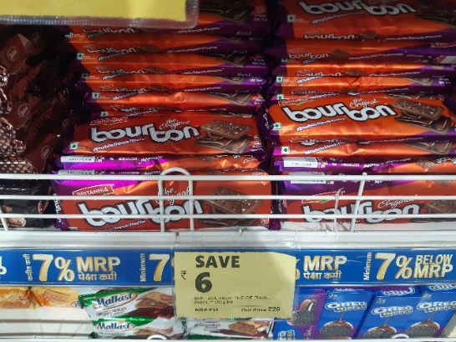 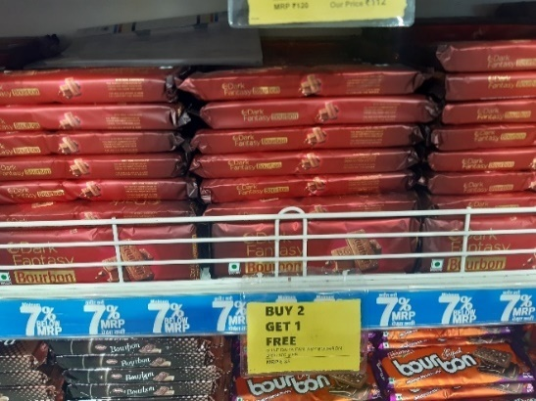

**Fig.6**

In the above figure we can observe that Britannia bourbon sales is higher that Sunfeast Bourbon.

**Britannia Good day 200g Vs Sunfeast Moms magic 200g**

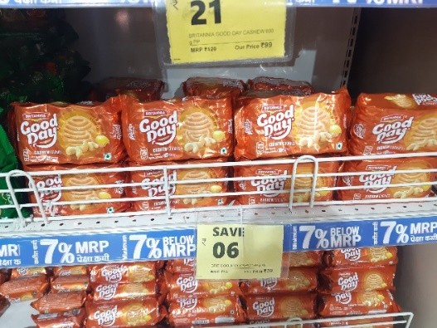 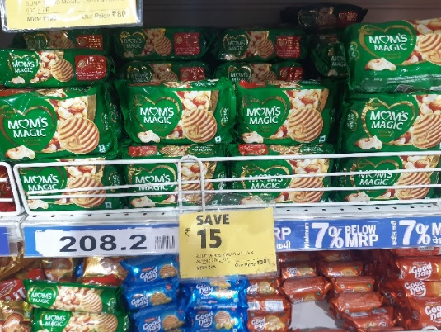

**Fig.7**

In the above figure we can observe that Britannia Goodday sales is higher that Sunfeast Momsmagic.

**Britannia Goodday 600g Vs Sunfeast Momsmagic 600g**

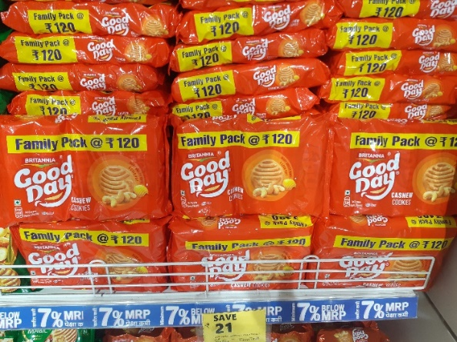 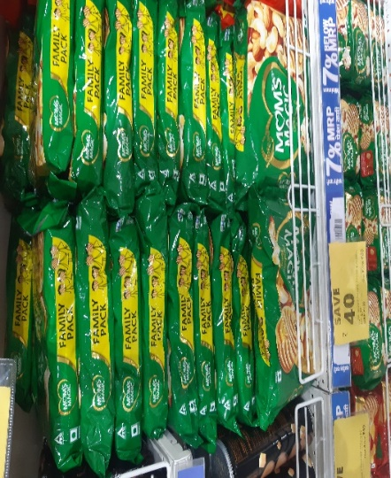

**Fig.8**

In the above figure we can observe that Britannia Goodday600g sales is higher that Sunfeast Momsmagic600g.

**Britannia Marigold 1kg Vs Sunfeast Marielight 1kg**

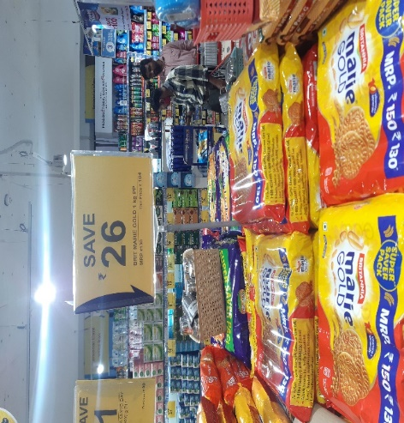 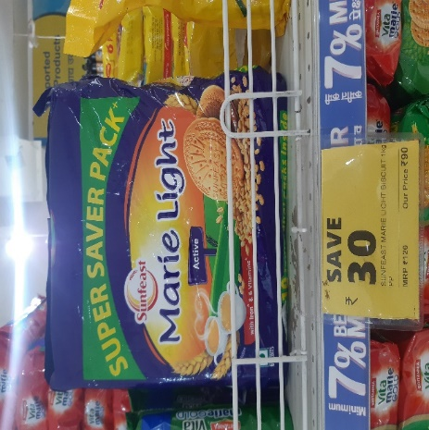

**Fig.9**

In the above figure we can observe that Britannia Marigold 1kg sales is higher that Sunfeast Marielight 1kg.

**Overall Comparison of Britannia and Sunfeast**

|  |  |  |  |
| --- | --- | --- | --- |
| **Britannia** | **Sunfeast** | **Britannia** | **Sunfeast** |
| Bourbon | Bourbon | 927 | 320 |
| Goodday 200gms | Momsmagic 200gms | 468 | 59 |
| Goodday 600gms | Momsmagic 600gms | 677 | 72 |
| Marigold 1kg | Marielight 1kg | 389 | 214 |

**Fig.10**

From the above graph we can predict that the Britannia product sales is higher than the Sunfeast products. As we all know that Britannia is the leading biscuits player in India with the market capitalization over 28% in the market.

## 6.2: Limitations & Future Scope

So, the limitation that I faced while working on this project was the time constraint. It is obvious that during these 45 days of span you cannot expect to learn more things are I learned to communicate with the people, consumer behaviour how the Retail store works every day. There were some limitations that I count do in the store because I wasn’t part of Reliance retail stores then need to improve on the Management of the store and communication of the employee with the customer. The biggest limitation was I was not able to order the stock of the biscuits sometimes the biscuit was used to go out of stock for 3-4 days but the employee was careless to order the stock. Goodday 100g was not in the rack for more than in a week I used to tell the DM to check the availability of the stock but they were careless so this was the biggest limitation I faced when I used to work in Reliance Retails

The company aims to include new products in the traditional link of brand and product. Britannia Industries Ltd intends to add new items to its existing brands in order to broaden their appeal. This would free the current brands from their traditional image, said Ms. Richa Arora, General Manager, Head - Marketing & Innovation, Britannia Industries Ltd. The company recently introduced its second product, dubbed "Fruit Rolls," in Tamil Nadu and Maharashtra under the Treat brand (best known for cream biscuits). There are four rolls in each pack, which costs Rs 10, and they come in apple, strawberry, orange, and dates flavours. According to Ms. Arora, there are plans to introduce a third product under Treat. Fruit Rolls matches Treat's idea of "discovering hidden treasure inside the product pack," which has been ongoing. In actuality, the Treat cream biscuits' family is depicted in the Fruit Rolls television commercial.

The business estimates revenues from "Fruit Rolls" to be around Rs 24 crore (15% of the Rs 160 crore Treat Brand) over the coming year, and it has budgeted roughly Rs 3 crore for advertising for the Treat brand. The business has partnered with Radio Mirchi for an advertisement spot in addition to print and television commercials. Additionally, it will hold tournaments for kids at 400 schools in Bangalore, Chennai, Mumbai, New Delhi, and Kolkata. The company is in discussions with publishers, booksellers, and retail establishments to release a children's book as well. A third party is now producing Fruit Rolls in West Asia, and it's expected that production will eventually move to India.

## 6.3: Suggestions

* Britannia can improve the quality of packaging of their products which can attract more customer attraction and can increase their sales of the product.
* Instead of using Film stars in the advertisement they can use small actors which can perform better & Britannia is a big brand which doesn’t need much advertisement they need to just spared awareness of the products.
* They should expand their business overseas to capture the market of biscuits and they can gain more revenue.
* Britannia can start giving offers like Buy 1 Get 1 free, buy 2 Get 1 free and many more from this we can attract more customers.
* They can more focus on Cake segment to gain more revenue.

# 7: Conclusion

The time has come to create the entire picture after going thick on the subject. Retailers consider the GMROI (Gross Margin Return on Investment) when creating an SKU (Stock Keeping Unit) for a product and promote the brands that offer them the best GMROI. They anticipate a return in the form of profit margin, corporate plans, window displays, and store referrals. Company initiatives stand out among them and are, after profit margin, the most powerful motivators. The corporation must always push itself in retail.

In order to appeal to discerning consumers and retail drive to attract a variety of consumers, marketers must utilise branding and advertising techniques. Because retailers cannot control quality and price, the producer should be aware of consumer behaviour. Only the dealers can decide whether to sell given the demand. Britannia nearly half agreed that consumers at retail stores choose their biscuits based on brand recognition.

It is very essential to know how retailers behave since seeing them as members of a team who work for the same company may strengthen their bond with it. Inside of the stores should be a sense of belonging to the company. Creating a values club for merchants will allow them to share their perspectives with the business and aid in better understanding consumer behaviour.

# 8: Bibliography

* <https://en.wikipedia.org/wiki/Britannia_Industries>
* <https://economictimes.indiatimes.com/industry/cons-products/fmcg/pandemic-brought-significant-shifts-in-consumer-preferences-says-britannia-industries/articleshow/86002872.cms>
* <http://britannia.co.in/about-us/overview>
* <https://www.exchange4media.com/advertising-news/britannia-to-expand-scope-of-brands-24112.html>
* <https://www.coursehero.com/file/p5pr3lp/KRA-OF-THE-ORGANIZATION-The-following-are-the-key-result-areas-that-the/>
* <http://britannia.co.in/pdfs/annual_report/Annual-Report-2020-21.pdf>
* <https://www.techsciresearch.com/blog/top-5-challenges-biscuit-manufacturers-will-face-in-2018/83.html>
* <https://www.indianretailer.com/article/whats-hot/news-feature/Why-Indian-Biscuit-Industry-is-Not-Shining.a5928/>
* <https://www.google.com/search?q=market+share+of+britannia+biscuits+in+india&tbm=isch&source=iu&ictx=1&vet=1&fir=KzK2yQHVWJTFuM%252CIvedpLBd09_d0M%252C_%253BbOsVSdvSBf2mjM%252CAvFpHChYixTJoM%252C_%253BKDKAWZqf7ibd0M%252CAvFpHChYixTJoM%252C_%253BfzmaRiqXTNGCOM%252CLaSWcUsseM2JNM%252C_%253B1ij8Dxo0XQ9sHM%252CAvFpHChYixTJoM%252C_%253B4cZMVcM5gWTuzM%252CphoumsYgcFQ_9M%252C_%253B7VcVViUiG_rH2M%252CE5EPLVhqBtFDBM%252C_%253BaFhew23iYKE62M%252C8Is3lbsnqzHWCM%252C_%253BJVZ4_ccn5rJ9PM%252C3yaeFiwx9_Gb8M%252C_%253Bxjcv4pq6G9hptM%252CLCXzJcyn_dDvdM%252C_&usg=AI4_-kQ_4BXIrJfk0V4ieVzMT9uVfMLIbQ&sa=X&ved=2ahUKEwiNrYO2v5T5AhUjjdgFHXjuCusQ9QF6BAglEAE#imgrc=KzK2yQHVWJTFuM&imgdii=aFhew23iYKE62M>
* <https://www.industryarc.com/Report/16682/biscuits-market.html#:~:text=Biscuits%20Market%20Overview,the%20forecast%20period%202020%2D2025>.
* <https://www.google.com/search?q=britannia+industries+growth&source=lnms&tbm=isch&sa=X&ved=2ahUKEwiW0ODo7qr5AhVoxYsBHQ3yBaoQ_AUoAnoECAEQBA&biw=1517&bih=721&dpr=0.9#imgrc=xjcv4pq6G9hptM>
* <https://indiancompanies.in/top-best-biscuit-brands-in-india/#:~:text=Indian%20Biscuit%20Market%20size%20is,the%20largest%20category%20within%20FMCG.&text=Britannia%2C%20Parle%20and%20ITC%20control,for%2092%25%20of%20the%20segment>.
* [www.Britannia.com](http://www.Britannia.com)
* <https://economictimes.indiatimes.com/britannia-industries-ltd/shareholding/companyid-13934.cms>